# PRACTICAL NO.1

**AIM : Use Google and Whois for Reconnaissance.**

**Steps:**

1. Open the WHO.is website
2. Enter the website name and hit the “Enter button”.
3. Show you information about [www.prestashop.com](http://www.prestashop.com/)

# Using who.is

**Step1:** Open the WHO.is website

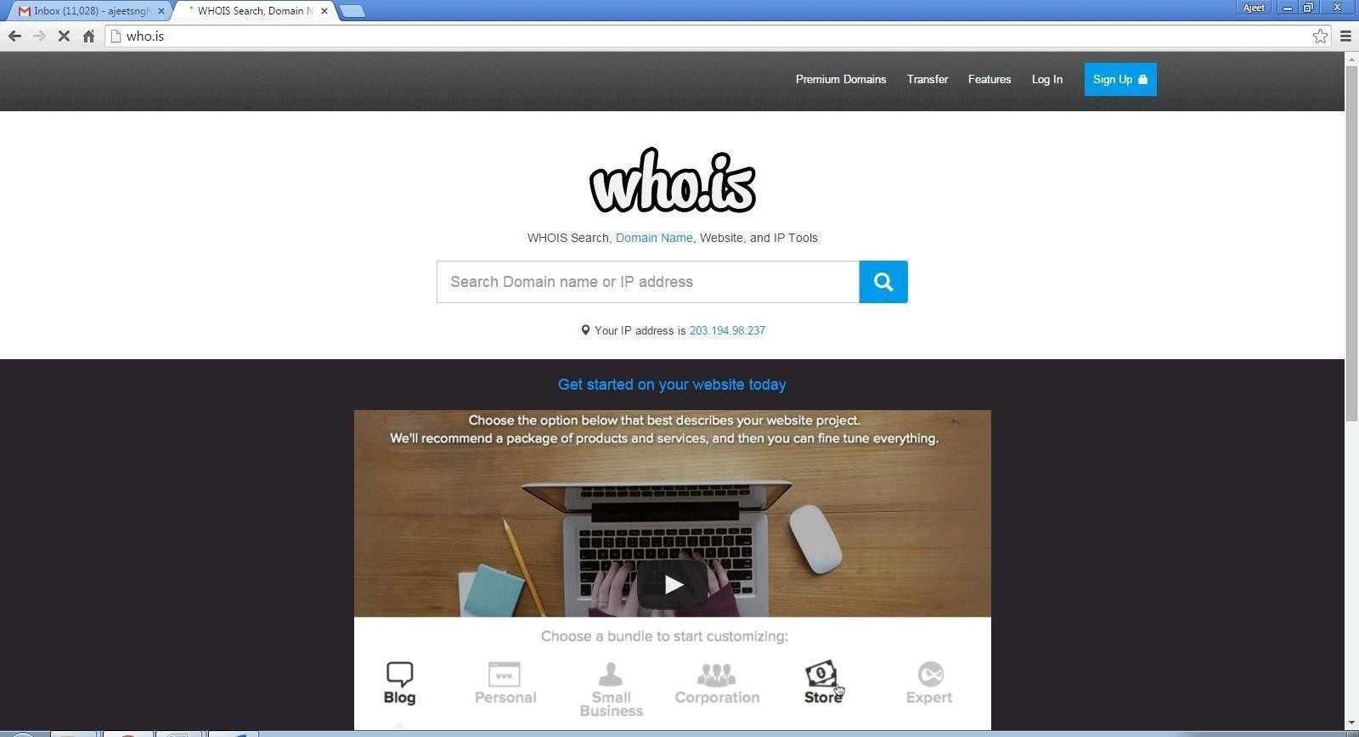

**Step 2:** Enter the website name and hit the “Enter button”.

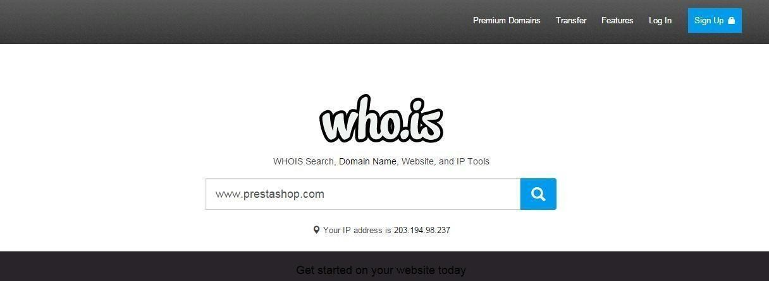

**Step 3:** Show you information about [www.prestashop.com](http://www.prestashop.com/)

